Requesting Faculty Notification Letters in MinerAccess

Step 1: Log into MinerAccess using your S&T username and password.
Step 2: Access the Dashboard
- After logging in, you’ll land on the My Dashboard.
- Look for the Accommodation Requests section.
Step 3: Add New Requests
- Click the Add Requests button (located below the plus symbol).

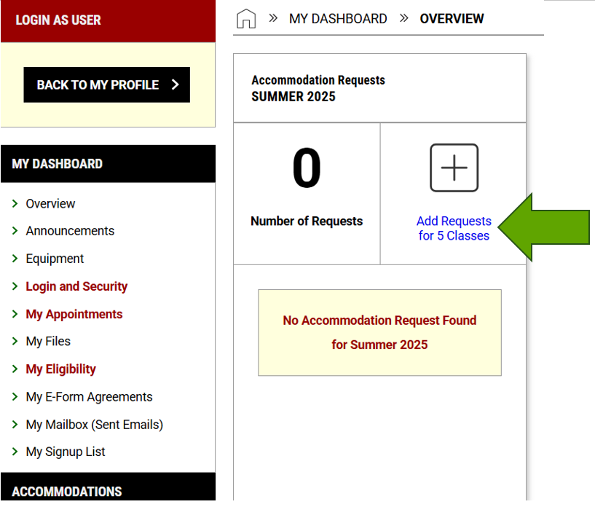

Step 4: Select Your Courses
You’ll be taken to the Select Courses screen.
- Choose the courses for which you want to request accommodations.
- You can select multiple courses at once.
- Optionally, check the box to apply the same accommodations to all selected courses (only if appropriate).
- Select Continue to Next Step
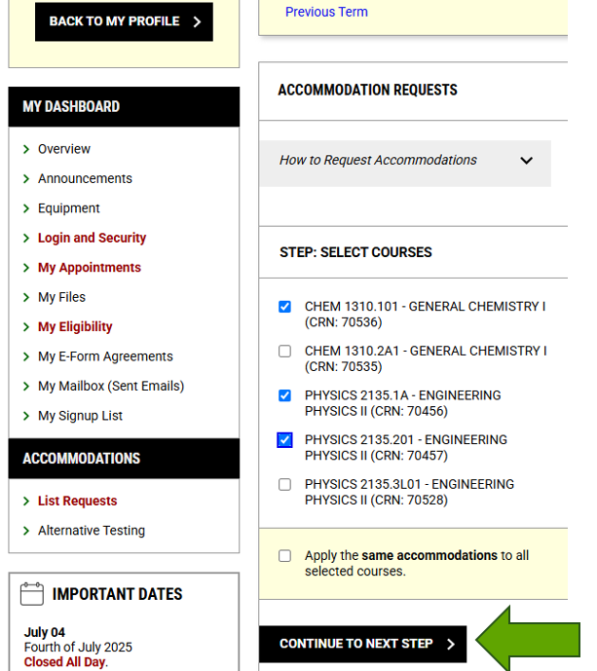

Step 5: Choose Accommodations
For each course, select the specific accommodations you need. You can:
  - Select accommodations individually.
  - Use “Select All” to request all approved accommodations.
  - Choose “No accommodations needed” if applicable.

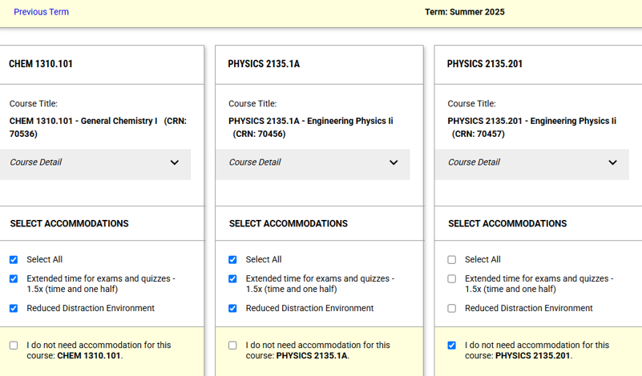
Step 6: Submit Your Requests
- Review your selections.
- Read and check “Accommodation Agreement”
- Click Submit Request to finalize.

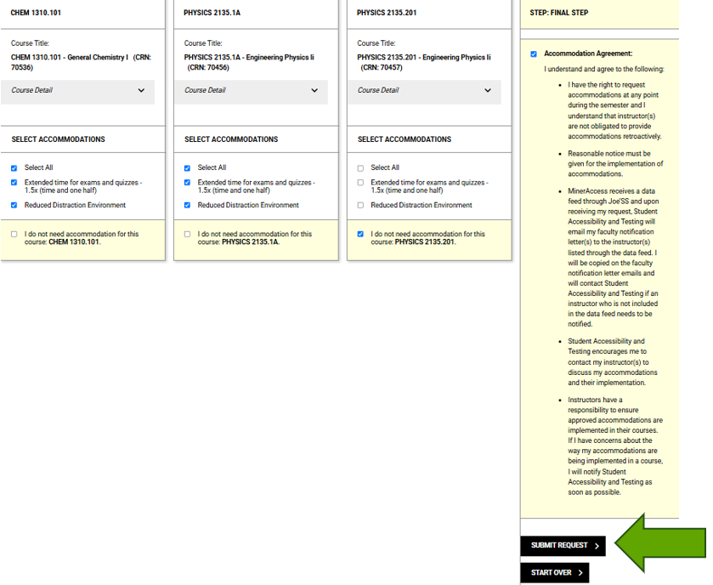

Step 7: Notification and Delivery
- Once approved, Faculty Notification Letters will be emailed to your instructors.
- You and your instructors will receive a copy.
- Processing may take up to 3 business days.
Notes:
- Submit early: If you submit before the semester starts, letters may be held until 1–2 weeks before classes begin.
- Review carefully: Only request accommodations that are relevant to each course.
- Cancel if needed: You can cancel requests for a course at any time.

